江阴市小学英语学科六年级毕业考试纲要（试行稿）
江阴市教师发展中心

一、指导思想
小学英语六年级考试纲要依据《义务教育英语课程标准》和现行《义务教育教科书》（英语English）六年级上、下册，并结合江阴市小学英语教学的实际情况而制定。注重考查六年级学生必须具备的语言知识和听读写三方面的语言技能，试卷保持较高的效度、信度以及必要的区分度和适当的难度。
二、考试范围
语法和日常交际用语限于现行《义务教育教科书》（英语English）六年级上、下册第一至第八单元，词汇也限于这一范围所列出的单词、短语和习惯用语。语音包括五个元音字母、辅音字母和部分字母组合的常见发音。
三、考试要求
考试要求采用双向细目表予以说明，双向细目表由“知识点”和“能级要求”两栏组成。在“知识点”一栏中列出了六年级上、下册应测试的知识要素细目，在“能级要求”一栏中用识记、理解、应用三级表示知识点应达到的考试水平。
各能级的含义大体是：识记指记忆学过的知识，理解指领会所给语言材料的含义，应用指直接用已获得的知识去解决新情景中的问题。

类 别 |  | 知 识 点 | 能 级 要 求
 |  | 知 识 点 | 识记 | 理解 | 应用
语言知识 | 语音 | 六年级上册  1. 字母组合ar 在单词中的读音/ a: /  2. 字母组合ear在单词中的读音/ iə /  3. 陈述句的语调（降调）。  4. 字母组合er在单词中的读音/ ə /  5. 字母组合ir在单词中的读音/ɜ: /  6. 句子的升调和降调。  7. 字母组合oo在单词中的读音/ u: /  8. 字母组合oo在单词中的读音/ u /  六年级下册  1. 特殊疑问句的降调。  2. 字母组合or在单词中的读音/ ɔ: /  3. 字母组合ou在单词中的读音/ aʊ/  4. 句子的重读。  5. 字母组合ow在单词中的读音/ əʊ /  6. 字母组合air在单词中的读音/ eə /  7. 字母组合oy在单词中的读音/ ɔi /  8. 单词在句中的连读。  五个语音字母和辅音字母的常见发音 | √ | √ | √
语言知识 | 词汇 | 六年级上册  四会单词：  laugh, wear, say, tell, start, little, next, turn, child, sunny, become, windy, cloudy,  sky, bring, drink, rainy, meet, holiday, ask,  National Day, Great Wall, excited, paper,  bottle, at first, ago, office, newspaper, news, watch, e-book, with, yesterday, sign, shopping centre, careful, mean, floor, around, keep, clean, make, dirty,  museum, ground, use, much, oil, drive, other, glass, collect, get, next week, food, rich, plan  六年级下册  四会单词：  large, strong, quietly, weak, loudly, happily, habit, never, late, finish, tidy, fast, healthy, diet, a little, a few, need, road, must, safe, follow, light, Children's Day, begin, end, country, will, learn, welcome, visitor, like, month, go back to, how long, photo, travel, dream, future, tooth, take care of, scientist, artist  六年级上册  三会单词：  long long ago , magic, clever, foolish, through, each, sentence, quick, think, hard, turn into, show, interesting, weather,  high, honey, ant, bee, cloud, rain, lose, know, climb up, hold onto, fly away, call,  Bund, Shanghai Museum, star, go well,  Palace Museum, Tian'anmen Square,  Fashion show, heavy rain, then and now,  Use, telephone, mobile phone, anywhere,  radio, make friends, all over the world, TV, look out of, still, go on, spell, litter,  make a sentence, go in, take...into, smoke,  restaurant, someone, smell, outing, walk on, smoke, air, rubbish, messy, dead, bin,  move...away from, plant, more, throw, skin, pick...up, slip, fall, protect, Earth, save, useful, waste, reuse, energy, most, come from, coal, wood, cut down, plastic,  too many, too much, project, poster, gate,  Hong Kong, tangyuan, Chinese New Year's Eve, Chinese New Year's Day, red packet, lion dance, fireworks, firecracker, hooray, light  六年级下册  三会单词：  mouse, walk by, wake...up, some day, let...go , the next day, net, bite, sharp, sadly, just then, soon, from then on, cheer,  hit, deep, reach, quickly, pour...into, bad,  put..in order, sleepy, last night, go into, slowly, badly, at a time, cola, safety, cross,  safely, zebra crossing, pavement, look out for, easily, rule, stay, clown, appear, ballon, put on, find out, magazine, koala,  kangaroo, sport-lover, Australian football,  exciting, Sydney, for example, London,  Oxford, Big Ben, London Eye, Tower Bridge, summer holiday, stay, sound, Taipei, Disneyland, Ocean Park, traveller,  travel around the world, different, care about, astronaut, spaceship, dancer, brave,  football player, World Cup, pianist, come true, paint | √ | √ | √
语言知识 | 语法 | 六年级上册  一、一般过去时的陈述句（肯定和否定）、一般疑问句（及其肯定和否定回答）。  二、Be 动词和规则动词的过去式构成及其读音。  1. Be 动词的过去式：is/am---was are--- were  2. 规则动词的过去式：  1）直接加ed：work—— worked look——looked  2） 以不发音e结尾的单词，直接加d：live ——lived hope——hoped  3）以辅音字母+y结尾的，变y为i加ed：study—— studied  4）以一个辅音字母结尾的，双写最后的辅音字母+ed：stop—— stopped plan——planned  3.不规则动词的过去式：catch--- caught eat --- ate wear--- wore can --- could get --- got go --- went go --- went see --- saw become --- became say---said  fly --- flew take --- took lose --- lost bring---brought read---read write---wrote make---made find --- found get --- got come --- came have / has--- had do, does--- did  take --- took  4.规则动词过去式的读音：  1) 在浊辅音和元音后读/d/。如：lived, listened.  2) 在清辅音后读/t/。如：helped, liked, watched.  3)在/t/和/d/的后面读/id/。如：wanted, tasted.  三、一般过去式特殊疑问句 (及其回答）。特殊疑问词：what/where/when /why/who/how...  四、谈论公共标识的问答句型和常用的文字标识句型，即No+doing（动名词）结构。  五、make / keep+名词+形容词的结构。如：make our city beautiful ; keep the air clean.  六、情态动词can表示（可以）的新用法。如：We can plant more trees.  七、use...to... 的用法及情态动词should和shouldn’t的用法。  八、too many和too much的区别和运用。  九、一般将来时态be going to...结构的肯定句和特殊疑问句（及其回答）。  六年级下册  一、动词和副词在句中的搭配使用，以及形容词和相应副词在词形上的联系和用法上的区别。  副词的构成：  1、大部分的副词由形容词加-ly构成，例如:slow—slowly; quick—quickly; bad—badly ；quiet—quietly ; sad—sadly; loud--loudly; excited--excitedly  2、以-y结尾的形容词把-y变为-i，再加-ly，例如：happy(快乐的)—happily（快乐地）; easy（容易的）—easily（容易地）; lucky（幸运的）--luckily（幸运地）  3、与形容词同形的副词。例如：early(早的)–early（早）；fast(快的)—fast（快）  二、不规则动词的过去式：bite--bit, let--let, wake--woke, say--said  三、a lot of, some, a few, a little与名词的搭配用法。  四、情态动词must和mustn't的用法；must 和can的区别。  五、一般将来时be going to的特殊疑问句和一般疑问句及其回答。  六、“助动词will+动词原形”构成的一般将来时的陈述句，一般疑问句、特殊疑问句及其回答。  七、want to be/ do结构的用法。 | √ | √ | √
语言技能 | 听 | 能听懂没有生词、浅于所学语言知识的录音材料；语速为每分钟70—80个词，完成对话和短文听三遍，其余听两遍，理解正确率达到80%。 |  |  | √
语言技能 | 读 | 能独立阅读所学语言知识范围内的材料，生词率不超过1%，阅读速度为每分钟30—40个词，理解正确率达到80%。 |  |  | √
语言技能 | 写 | - 有良好的书写习惯，能用书写体熟练清楚地书写，大小写、笔顺、词距、标点正确。  - 能听写与所学内容相关、没有生词的语言材料，语速为每分钟70—80个词（第一遍只听不写，第二遍边听边写，第三遍检查。书写速度为每分钟8个词左右，所写词汇限于“四会”要求的单词）  - 能笔头回答就课文内容或根据实际情况提出的问题。  - 能在所学词汇、语法和句型的范围内完成相关题目。  5、能根据所给提示完成短文。 |  |  | √

四、考试形式与试卷结构
（一）考试形式
闭卷、笔试。考试时间为60分钟，试卷满分为100分。
（二）试卷难易比例
试卷包括容易题、中等题和难题，其中以中等题为主。
（三）试卷整体结构、题型和分值

类别 | 题型 | 题数 | 计分
听  力  部  分 | 一、听录音，选择听到的内容，将其序号写在题前括号内。（听两遍） | 10题 | 10分
听  力  部  分 | 二、听录音，选择正确的应答，将其序号写在题前括号内。（听两遍） | 5题 | 5分
听  力  部  分 | 三、听录音，根据听到的对话和问题选择正确答案，将其序号写在题前括号。（听两遍） | 5题 | 5分
听  力  部  分 | 四、听录音，根据所听到的短文内容，填入所缺单词。（听三遍） | 10题 | 10分
笔  试  部  分 | 五、选出划线部分发音与其余三个不同的选项。 | 5题 | 5分
笔  试  部  分 | 六、中英互译。 | 10题 | 10分
笔  试  部  分 | 七、根据所给单词的适当形式或首字母提示，完成句子。 | 10题 | 5分
笔  试  部  分 | 八、单项选择，将所选答案的序号填入题前括号内。 | 10题 | 10分
笔  试  部  分 | 九、从Ⅱ栏中找出与Ⅰ栏中句子匹配的正确选项，将其序号写在题前括号内。 | 10题 | 5分
笔  试  部  分 | 十、根据实际情况回答下列问题,要求答句完整。 | 5题 | 10分
笔  试  部  分 | 十一、根据首字母和上下文提示，填入所缺单词，使短文意思完整。 | 10题 | 10分
笔  试  部  分 | 十二、阅读理解  A. 阅读短文判断下列句子的正误，正确的写“T”，错误的写“F”；  B. 根据短文内容，选择正确答案。 | 2题 | 10分
笔  试  部  分 | 十三、根据中文提示，将下面的短文填写完整 (每空一词)。 | 1题 | 5分
备注： 其他参考题型
听力部分：
一、听录音，用阿拉伯数字给下列图片标号。（听两遍）（5、6题 5分）
笔试部分：
一、按要求改写下列句子。
二、根据汉语提示完成下列句子，每空一词。
五、考试样题
听力部分：
一、听录音，选择听到的内容，将其序号写在题前括号内。（听两遍）
( )1. A. shall B. show C. shout
听力材料：There was a parrot show in the park this morning.
二、听录音，选择正确的应答，将其序号写在题前括号内。（听两遍）
( )1. A. He eats moon cakes with his parents. B. He is going to watch the moon.
C. He had a big dinner with his family.
听力材料：What is Mike going to do this weekend ?
三、听录音，根据听到的对话和问题选择正确答案，将其序号写在题前括号。（听两遍）
( )1. A. No climbing. B. No parking. C. No photos.
听力材料: A: Look! There is a beautiful picture .
B: Yes. I like it very much. Let’s take photos there.
A: No, we can’t . There is a sign beside it .
B: Oh, I see .
Question: What does the sign mean ?
四、听录音，根据所听到的短文内容，填入所缺单词。（听三遍）
Today is May 29th . __________ _________ is coming . We ________ have a party at school on that day . There will be many snacks and drinks . Linda will ______ some songs at the party. Her _______ is to be a singer. Alice will play the piano. She likes ______ the piano . Ben will take _______ for us . Nancy and Mike will ______ the play The King’s new clothes. I like painting. I will draw a picture . I want to be an ________ . And there will be a guessing game too. I will _________ a present if my answer is right. I think we’ll be very happy and will laugh ________ at the party.
听力材料：
Today is May 29th . Children’s Day is coming . We will have a party at school on that day . There will be many snacks and drinks . Linda will sing some songs at the party. Her dream is to be a singer. Alice will play the piano. She likes playing the piano . Ben will take photos for us . Nancy and Mike will act the play The King’s new clothes. I like painting. I will draw a picture . I want to be an artist . And there will be a guessing game too. I will get a present if my answer is right. I think we’ll be very happy and will laugh happily at the party.
笔试部分：
五、选出划线部分发音与其余三个不同的选项。
( ) 1. A. danger B. date C. many D. change
六、中英互译。
1.收集一些纸 some 2.all over the world
七、根据所给单词的适当形式或首字母提示，完成句子。
1. I _____________________ (visit) the Summer Palace tomorrow.
2. To k the classroom clean, we should sweep the floor every day.
八、单项选择，将所选答案的序号填入题前括号内。
( )1. | Mid-Autumn Festival is in ________________. People usually __________.
 | A. January or February, play with lanterns
 | B. September or October, eat moon cakes
 | C. March or April, make chocolate eggs
 | D. May or June, eat rice dumplings
九、从Ⅱ栏中找出与Ⅰ栏中句子匹配的正确选项，将其序号写在题前括号内。
( )1. Why are you so sad? A. We can reuse it to make raincoats.
( )2. What did you do yesterday evening? B. I did my homework at home.
( )3. Danger! You shouldn’t do that. C. Because I lost my purse.
( )4. This pretty doll is for you. D. No, I didn’t.
( )5. Where did they watch the cartoon? E. It’s Wednesday.
( )6. Did you see a film last weekend? F. In Yang Ling’s home.
( )7. What day is it today? G. Thank you.
( )8. How can we reuse plastic? H. I’m sorry.
十、根据实际情况回答下列问题,要求答句完整。
1. What did you do for the National Day holiday?
_____________________________________________________________________
十一、根据首字母和上下文提示，填入所缺单词，使短文意思完整。
Today is C_________ Day. But I am ill. I am at home now. My house is n_______ my school. From the window I can s________ some boys p__________ football in the playground. I want to play with them but I c______. Look at the tall man w______ glasses. He’s our teacher Mr. Huang. And the boy is my friend Jack. His n__________ is ten, Jack likes football very much. B________ today he is late. Listen, Mr. Huang is shouting a_______ him, “Come on Jack. It’s y________ turn now.”
十二、阅读理解
A. 阅读短文判断下列句子的正误，正确的写“T”，错误的写“F”。
We need clean water in our daily life, but now the water of many rivers is dirty. It is a big problem (问题).What can we do to keep the water clean and save water?
In our daily life, sometimes we don’t turn off the taps after cleaning our hands. Sometimes we throw rubbish into the rivers. It’s too bad. We should stop doing these things. I think we can reuse the water. For example, after washing something, we can water the flowers or sweep the floor with the water we used. Water is important. Let’s keep it clean and save it.
( )1. Dirty water is a big problem.
( )2. All the rivers are clean now.
( )3. We can’t throw rubbish into the river.
( )4. We should turn on the taps after cleaning our hands.
( )5. We shouldn’t reuse the water.
B. 根据短文内容，选择正确答案。
Mother’s Day is a holiday for mothers. People celebrate（庆祝）it in the USA, the UK and some other countries. Mother’s Day comes on the second Sunday in May. On that day, many people send presents of love to their mothers. They often wear pink or red roses or carnations（康乃馨) if（如果）their mothers are still living（活着）. If their mothers are not living, they wear a white one.
The idea of a day for mothers was first from Miss Anna Jarvis of America. Because of her hard work, people celebrated the first Mother’s Day on May 10, 1908.
In China, many people do the same on the day for mothers now. Some people choose a song on the radio for Mother.
( )1. | Mother’s Day was first celebrated _______.
 | A. in America |  | B. in England |  |  | C. in Japan | D. in France
( )2. | People started to celebrate Mother’s Day _______.
 | A. ten years ago |  | B. in 1980 |  |  | C. in 1890 | D. in 1908
( )3. | Mother’s Day always comes on _______.
 | A. May Day |  |  | B. May 15th
 | C. the second Sunday in May |  |  | D. May 10th
( )4. | Lily’s mother died（去世) three years ago. Every Mother’s Day, she wears_______.
 | A. a white rose | B. a yellow rose |  |  | C. a pink carnation |  |  | D. a red carnation
( )5. | On Mother’s Day, some people choose a song on the radio for Mum to _______.
 | A. spend some money |  |  | B. show their love
 | C. get some presents |  |  | D. sing
十三、根据中文提示，将下面的短文填写完整 (每空一词)。
我们的生活变化很大。
以前我们给父母亲写信，用座机打电话，从广播或报纸了解新闻，去商店买东西。
现在我们可以用手机在任何地方通话。在英特网上，我们可以交友，购物，互相交流等。
足不出户，就能办很多事，真是太棒了。
Our life changes a lot.
We ___________ ___________ to parents before. We ___________ the telephone to call people. We got news from the radios or ___________. We ___________ things from the shop.
But now we use mobile phones to call people anywhere. On the Internet, we can ___________ ___________, do ___________, ___________ with each other and so on. We can do ___________things at home. That’s great!
备注： 其他参考题型
听力部分：
一、听录音，用阿拉伯数字给下列图片标号。（5、6题 5分）
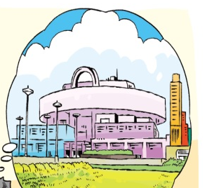
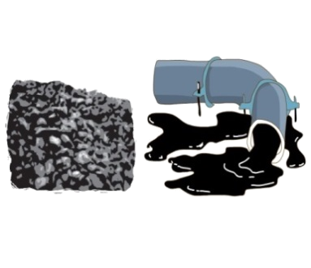

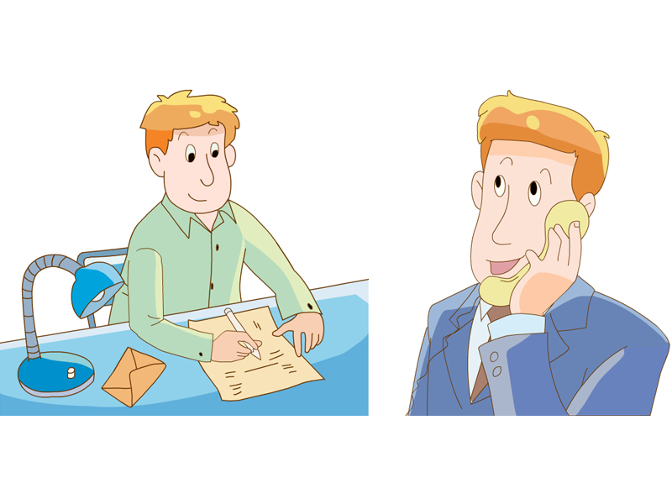
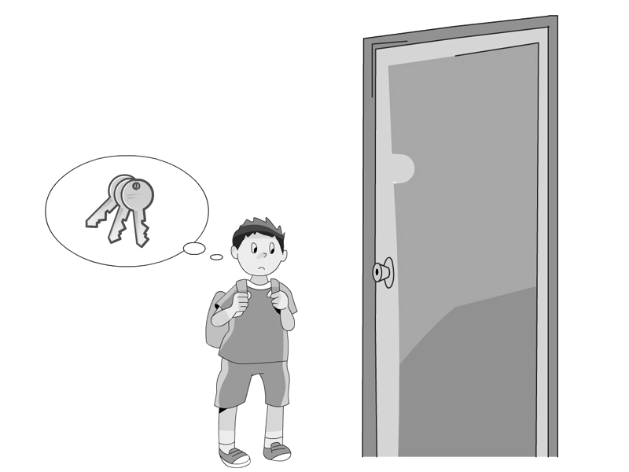
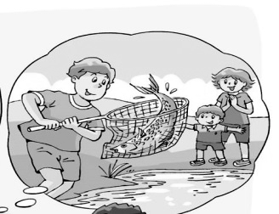

( ) ( ) ( ) ( ) ( ) ( )
听力材料：
1．There’s not much coal or oil on Earth. We should save energy.
2．I like Thanksgiving Day. It’s a very important holiday in the US.
3．W: Did you go shopping yesterday?
M: No, I didn’t. I went fishing with my family.
4．The boy lost his keys and he can’t open the door.
5. We visited the Shanghai Museum last summer holiday. That was great fun.
6．Twenty years ago, Mr Brown wrote letters to his friends. Now he has a mobile phone to call people anywhere.
二、听录音，判断下列图片是否与录音内容相符，相符的用“T”表示，不符的用“F”表示 (听两遍)
1. 2. 3. 4. 5.
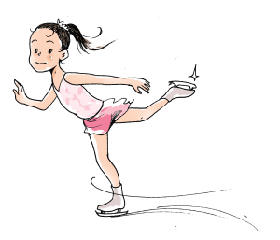
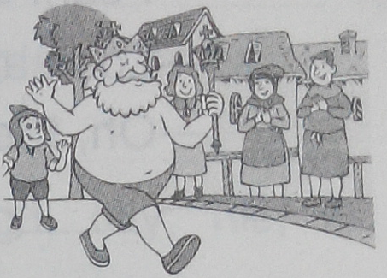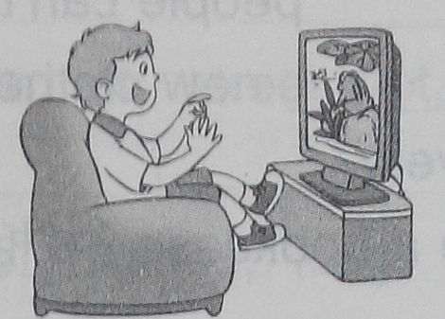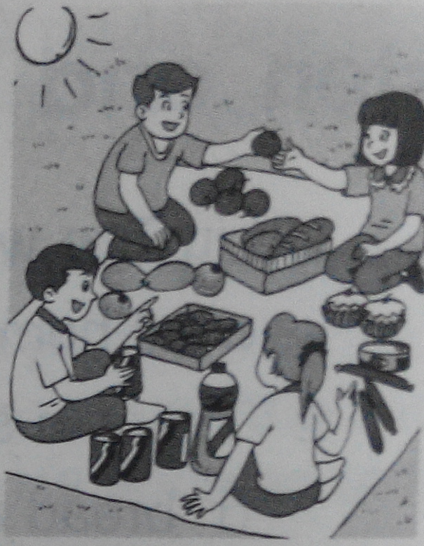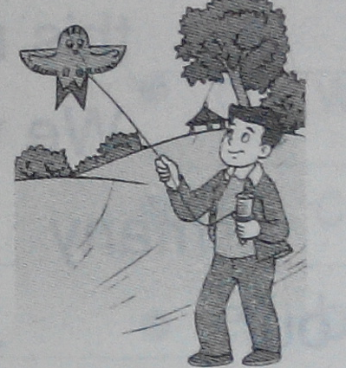
( ) ( ) ( ) ( ) ( )
听力材料：
The King isn’t wearing anything. He is a foolish king.
Did the boy watch a film in the cinema yesterday evening?
Yes, he did.
It’s sunny today. The children are having a picnic. They feel happy.
Oh, my balloon flies away. Who can help me catch it?
What’s your dream?
I want to be a pianist. Music makes people happy.
三、根据所听内容，完成调查记录表(每空一词)（听三遍）
Our survey
Place | beach
Day | last
Environment（环境） | messy and
Reasons（原因） | plastic , cans, lunch boxes and broken
Suggestions（建议） | should the rubbish in the  and make a on the beach
Suggestions（建议） | shouldn’t anywhere
听力材料：
We went to the beach last Friday. The beach was messy and dirty. What makes the beach messy? There were a lot of plastic bags, cans, and lunch boxes. There were some broken bottles, too. The pollution is serious.To keep the beach clean, we should put the rubbish in the bin and make a sign “No littering” on the beach. We shouldn’t litter anywhere. Everyone should know this.

笔试部分：
一、按要求改写下列句子。
1.I was ten years old last year.(改成一般疑问句)
__________ _________ ten years old last year?
2.This sign means we should not smoke here.(对划线部分提问)
__________ __________ this sign __________ ?
二、根据汉语提示完成下列句子，每空一词。
1.我明天将给我的堂弟写一封电子邮件。
I’ll ______ ______ ______ _________my cousin tomorrow.

