江阴市小学英语学科五年级下册考试纲要（试行稿）
江阴市教师发展中心

一、指导思想
小学英语五年级下册考试纲要依据《义务教育英语课程标准》和现行《义务教育教科书》（英语English）五年级下册，并结合江阴市小学英语教学的实际情况而制定。注重考查五年级学生必须具备的语言知识和听读写三方面的语言技能，试卷保持较高的效度、信度以及必要的区分度和适当的难度。
二、考试范围
语音、语法和日常交际用语限于现行《义务教育教科书》（英语English）五年级下册第一至第八单元，词汇也限于这一范围所列出的单词、短语和习惯用语。
三、考试要求
考试要求采用双向细目表予以说明，双向细目表由“知识点”和“能级要求”两栏组成。在“知识点”一栏中列出了五年级下册应测试的知识要素细目，在“能级要求”一栏中用识记、理解、应用三级表示知识点应达到的考试水平。
各能级的含义大体是：识记指记忆学过的知识，理解指领会所给语言材料的含义，应用指直接用已获得的知识去解决新情景中的问题。

类 别 |  | 知 识 点 | 能 级 要 求
 |  | 知 识 点 | 识记 | 理解 | 应用
语言知识 | 语音 | - 字母组合dr在单词中的发音/dr/。  - 字母组合tr在单词中的读音/tr/。  - 字母组合sh在单词中的常见读音  /∫/。  - 字母组合ch在单词中的常见读音  /t∫/。  - 字母组合ing在单词中的常见读音  / iŋ/。  - 字母组合qu在单词中的常见读音/kw/。  - 字母组合th在单词中的常见读音  /θ/ 和/ ð /。  8. 五个元音字母的常见发音 |  | √ | √
语言知识 | 词汇 | 四会：why, because, clothes, let, put on, have to, take off, moon, street, near, city, by, bus, on foot, metro, taxi, bike, plane, train, take, get on, get off, walk, hospital, shop, zoo, film, stop, feel, should, have a rest, toothache, anything, clean, cook, busy, garden, sweet, vegetable, tomato, potato, look for , love, bread, January, February, call, May, June，September，October， November， birthday, April, game, March, July, August， December， play，answer. | √ | √ | √
语言知识 | 词汇 | 三会：prince, fairy, before, try on , fit, mushroom, late, pick, understand, be bad for, leave…behind, far from, ship, ride, show, young, basket, ask the way, get to , station , bookshop, next to , ask…for help, along, turn right, traffic light, on your right, cinema, turn left, supermarket, full, over, see the doctor, check, take medicine, drink water, dentist, brush one’s teeth, bedtime, giraffe, point at , neck, parent, sweep the floor, wash the dishes, make the bed, grow, pest, ladybird, go away, game, smell, meat, ready, yummy, win, yeah, angry, spot, catch, drive…away, festival, Spring Festival, Chinese New Year, get together, dumpling, Dragon Boat Festival, dragon boat race, place , rice dumpling , Mid-Autumn Festival, moon cake ,Double Ninth Festival, old , mountain , rice cake ,Mother’s Day, Father’s Day , favourite, eleventh, eighth, together, hero, number, password, fourth, start, fight. |  | √ | √
语言知识 | 语法 | - 一般现在时态中动词第三人称单数形式的变化规则。  - 现在进行时态的陈述句，一般疑问句以及特殊疑问句。  - 祈使句的用法。  - 可数名词复数的变化规则。tooth-teeth, potato-potatoes tomato-tomatoes.  - 下列完整和缩略形式的表达。can’t=cannot, don’t =do not ,  shouldn’t=should not ,  when’s =when is  - Why are/can’t …?及其回答Because…  - Where do/ does …live?及其答…live/lives on /in…  - How do/does …come to school?及其回答…come/comes to school by…/on foot.  - Excuse me. How do I get to…?及其回答You can get on the metro/bus at…Then, walk to /go along…  - What’s wrong with you?  及其回答I have a fever/headache/  cold/toothache.  You should/ shouldn’t…  - What are you/they doing?及其回答I am/We are/They are sweeping the floor. What is he/she doing? 及其回答He /She is cooking dinner.  - Are you doing …?及其回答Yes， I am. No, I’m not.  - How is the meat/soup/…? 及其回答It’s yummy/nice.  - The Spring Festival is in January or February. People eat rice dumplings at this festival.  - When’s your birthday?及其回答It’s on …  - What do you do on your birthday? 及其回答I usually …  - put on, try on 和take off 的用法和区别，理解have to , be bad for, leave…behind 的意思，了解它们的用法。  - in, on ,by, far from 的用法  - get on ,get off , turn left, turn right，go along 的用法。  - take medicine, drink water, brush one’s teeth, have a rest 的用法。  - clean, cook, eat, help, wash, watch等动词现在分词的读音及用法。  - meat ,ready, spot, drive …away的用法。  - 12个月份对应的缩写形式。  - 序数词的构成和用法。 | √ | √ | √
语  言  技  能 | 听 | 能听懂没有生词、浅于所学语言知识的录音材料；语速为每分钟70—80个词，完成对话和短文听三遍，其余听两遍，理解正确率达到80%。 |  |  | √
语  言  技  能 | 读 | 能独立阅读所学语言知识范围内的材料，生词率不超过1%，阅读速度为每分钟25—30个词，理解正确率达到80%。 |  |  | √
语  言  技  能 | 写 | 1.有良好的书写习惯，能用书写体熟练清楚地书写，大小写、笔顺、词距、标点正确。  2.能听写与所学内容相关、没有生词的语言材料，语速为每分钟70—80个词（第一遍只听不写，第二遍边听边写，第三遍检查。书写速度为每分钟8个词左右，所写词汇限于“四会”要求的单词）  3.能笔头回答就课文内容或根据实际情况提出的问题。  4.能在所学词汇、语法和句型的范围内完成相关题目。  5.能根据所给提示完成短文。 |  |  | √

四、考试形式与试卷结构
（一）考试形式
闭卷、笔试。考试时间为60分钟，试卷满分为100分。
（二）试卷难易比例
试卷包括容易题、中等题和难题，其中以中等题为主。
（三）试卷整体结构、题型和分值

类别 | 题型 | 题数 | 计分
听  力  部  分 | 一、听录音，选出你所听到的内容 | 10 | 10
听  力  部  分 | 二、 二、听录音，判断是否否与图片相符 | 5 | 5
听  力  部  分 | 三、听录音，选择正确的应答 | 5 | 5
听  力  部  分 | 四、听录音，根据听到的对话和问题，选择正确的答案 | 5 | 5
听  力  部  分 | 五、听录音，完成对话或短文 | 1 | 5
笔  试  部  分 | 六、单词辨音 | 5 | 5
笔  试  部  分 | 七、汉英互译 | 15 | 15
笔  试  部  分 | 八、选择题 | 15 | 15
笔  试  部  分 | 九、交际语匹配 | 10 | 10
笔  试  部  分 | 十、根据实际情况回答问题 | 5 | 10
笔  试  部  分 | 十一、阅读理解 | 2 | 10
笔  试  部  分 | 十二、书面表达（根据所给提示完成短文） | 1 | 5
备注：其他参考题型
听力部分
1、听短文（对话），回答相关问题或判断正误
2、听录音，给下列图片排序
3、听对话，完成表格
笔试部分
1、选择与所给单词划线部分相同的一项
2、按要求改写句子
3、根据上下文或首字母填空
4、根据情景完成句子
五、考试样题
听力部分
一、听录音，选出你所听到的内容
例：（ ） A. play B. place C. prince D. plane
听力内容：There is a party at the prince’s house.
答案： C
二、听录音，判断所听内容是否与图片相符，相符的用“T”表示，不相符的用“F”表示
1. 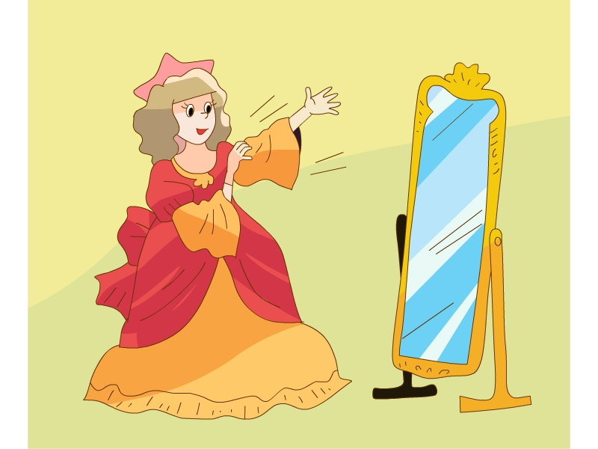（ ）2. 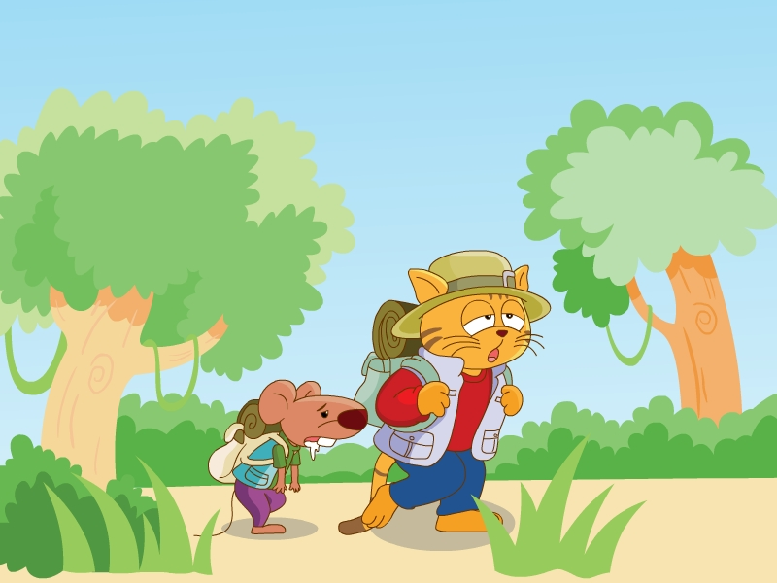 （ ）
听力内容：1. Cinderella puts on the new clothes and shoes.
2. Sam and Bobby are happy in the forest.
答案：1. T 2. F

三、听录音，选择正确的应答
例：（ ） A. Because I can’t go to the party.
B. So I don’t have any nice clothes or shoes.
C. Because I don’t have any nice clothes or shoes.
听力内容： Why can’t you go to the party?
答案： C
四、听录音，根据听到的对话和问题，选择正确的问题和答案
例：（ ） A. On foot. B. By bike. C. By bus.
听力内容：
A: Hi, Su Hai, where do you live now?
B: I live on Moon Street. So I go to school by bus. What about you, Yang Ling?
A: Oh, I live near school. I go to school on foot.
Question: How does Yang Ling go to school?
答案： A
五、听录音，完成短文
I have an e-friend, Jack. He is an English boy. He is twelve years old. His birthday is on the second of June. He lives near school, so he goes to school on foot. He likes running and playing football. He studies Chinese after school. He would like to come to China one day.
听力内容：略
答案：略
笔试部分
六、单词辨音
（ ） A. these B. their C. birthday D. then
答案： C
七、词汇
A：翻译词组
脱下你的外套 _______ ________ your coat
答案： take off
B: 用所给词的适当形式填空
It’s very cold now. Sam _______(have to) wear warm clothes.
答案：has to
八、选择
( ) A: Where do you live, Peter?
B: I live ______ Sun Street.
A. in B. on C. at
答案： B
九、交际语匹配
A．
（ ） 1. Do you go to school by bus? A. He is fine, thank you.
（ ）2. How is your father? B. He has a toothache.
（ ）3. What’s wrong with Sam? He looks sad. C. Yes, it’s interesting.
（ ）4. You shouldn’t eat too many sweets. D. Yes, I go with Mike.
（ ）5. Are you watching TV now? E. OK, thanks.
答案：1. D 2. A 3. B 4. E 5. C
十、根据实际情况回答问题
When is your birthday? ________________________________
答案： It’s on …
十一、阅读理解
A. 阅读短文并判断正误
Once up a time, there lived a black crow(乌鸦) in a small village. He drank water from the lake near the village.
Recently(近来) there was no rain and the lake was dry. The crow didn’t have any water to drink. He looked everywhere for water. One day, he saw a big bottle on the ground. There was only a little（一点，少量） water in it. Suddenly, he got an idea. He dropped（扔） many stones into the bottle. After a long time, the water came up to the top of the bottle. Now the crow could drink the water.
What a clever crow!
( ) 1. Long long ago, there was a black crow.
( ) 2. Recently the crow drank water from the lake near the village.
( ) 3. One day, the crow saw a big bottle with much water.
( ) 4. The crow could drink the water at last.
( ) 5. The crow was foolish!
答案：T F F T F
B．阅读短文并选择
One fine evening, a nice princess(公主) goes out to take a walk in a wood(森林). She plays a golden ball(金球) in her hand. Suddenly, her golden ball falls into a big hole on the ground. She is very sad then. At that time, a frog comes.
Frog： My beautiful princess, why do you cry?
Princess：Because my golden ball is in the hole. I can’t get it.
Frog：Don’t worry, I can help you. But can you promise(答应) me a kiss after you get the ball?
Princess：OK, I promise.
The princess gets the golden ball, but she doesn’t like the ugly frog. She runs away because she doesn’t want to kiss it. She talks to her father, the king, after she’s back home.
King：What’s the matter, my dear?
Princess：The frog is too ugly. I can’t kiss it.
King： Keep your words, darling. Go and invite(邀请) that frog to our dinner.
After dinner, the king asks the princess to sleep with the frog. She cries again. Her teardrops(泪珠) fall on the frog, it changes(变成) into a nice boy. He’s a prince!
At last, the princess and the prince live happily together.
( ) 1. Who are in the story?
A. The frog and the princess.
- The frog, prince and the king.
- The frog, the king and the princess.
( ) 2. Whose golden ball is it?
- The frog’s. B. The princess’. C. The king’s.
( ) 3. Why does the frog change into the prince?
A. The princess kisses the frog.
- The princess’ teardrops fall on the frog.
- The king helps the frog.
( ) 4. Which one is not true?
- The princess cries because her ball is in the hole.
- The princess doesn’t like the ugly frog.
- At last, the princess and the frog live happily together.
( ) 5. “Keep your words.” means “____________”.
- 信守诺言 B. 注意你的言语 C. 坚持你的观点
答案：1. C 2. B 3. B 4. C 5. A

十二、根据情景，完成短文
星期天的早上，天气真好！看，爸爸正在花园洗车。弟弟呢，他总不会袖手旁观。看，他正在帮爸爸。厨房里，妈妈正在做土豆烧肉。我正在洗水果，我想为大家做份水果色拉。这是我们的最爱。为什么我们会这么忙碌？因为我们将要去公园野餐。
It is Sunday morning. What a sunny day! My father is cleaning the car in the garden. My brother always helps us a lot. Look, he is helping father. In the kitchen, my mother is cooking meat with potatoes. I am washing some fruits. I want to make a fruit salad for us. We all like eating it. Why are we so busy now? Because we are going to have a picnic in the park.
答案： 略
备注：其他参考题型
听力部分
一、听录音，判断正误
( ) 1. Mr. Black goes to work in the morning.
( ) 2. Mrs. Black sees her friends in the afternoon.
( ) 3 .The children come home from school early.
( ) 4.Miss Li comes home from work late.
( ) 5. Mr. Green and Mrs. Green usually watch TV at night.
听力内容：
1. Mr. Black walks to work in the morning.
2. Mrs. Black sees her friends in the afternoon.
3. The children come home from school late.
4. Mrs. Li comes home from work late.
5. Mr. Green and Mrs. Green usually watch TV at night.
答案：1.F 2. T 3. F 4. F 5. T
二、听录音，给下列图片排序
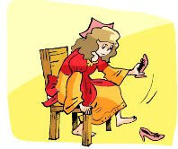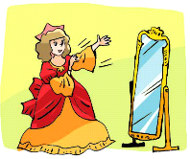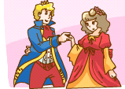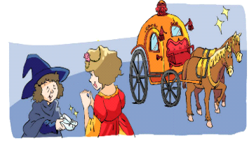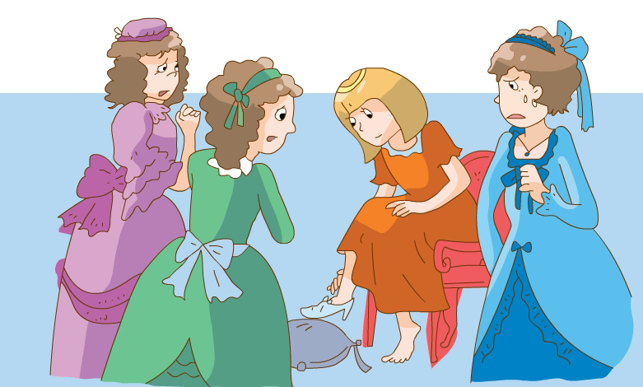
（ ） （ ） （ ） （ ） （ ）
听力内容：1. Cinderella puts on the new clothes.
2. Cinderella takes off the shoes.
3. Many girls try on the shoe.
4. A fairy comes and helps Cinderella.
5. Cinderella and the prince have a good time at the party.
答案： 2. 1. 5. 4. 3
三、听短文，完成表格
Name | John | Shirley
Age | __1__ | __2__
Hobbies | __3__and playing football | Drawing and___4___
birthday | the second of March | the__5__ of March
My name is John. I am fifteen years old. I live in the US. My parents are both doctors. I have a sister, Shirley. She is eight. I like swimming and playing football. But my sister doesn’t. She likes drawing and skating. My birthday is on the second of March. My sister’s birthday is in March too, but it’s on the ninth.
答案：1. Fifteen 2. Eight 3. Swimming 4. skating 5. ninth

笔试部分
一、选出与所给单词划线部分相同的一项
( ) 1. chair A. school B. Christmas C. teach
答案： C
二、按要求改写句子
1. Liu Tao is looking for some juice.(划线部分提问)
________ ________Liu Tao ________?
答案： What, is , doing
三、 根据上下文或首字母填空
Today is the first of June. It’s Children’s Day. We have no classes. We are having a party in the classroom now. Nancy is playing the piano. Yang Ling is dancing. What are Liu Tao and Wang Bing doing? Look, they are singing over there. What a happy day!
答案：略
四、根据情景完成句子
1. 南希感觉冷了，她应该穿上外套。
Nancy ______ cold. She ________ put on her coat.
答案：feels, should

